THEME: SPIRIT LED-SPIRIT EMPOWERED
The Holy Spirit helps us tell others about Jesus in a bold and loving way. Just like He gave the disciples power and special gifts, He also gives us what we need to share God’s love with our friends, family, and community. As we learn about these gifts, we will grow in confidence, kindness, and courage to be witnesses for Jesus every day.
Movers Shakers (9-12) Years
DATE | 26TH APRIL 2026
TOPIC | 1 Corinthians 12:4-11  The Holy Spirit Empowers Me to Witness Through His Gifts  (Word of Wisdom, Word of Knowledge, Faith)
LESSON OVERVIEW | Children will learn that the Holy Spirits helps us to tell others about Jesus through the gift of a message of wisdom, a message of knowledge and faith. They will learn that they are not alone and God gives them the right words, understanding and courage to witness.
TAKE AWAY | The Holy Spirit helps me tell others about Jesus with wisdom, knowledge, and faith.
PREPARATION | Read 1 Corinthians 12:4-11  Make sure you have visuals.
GAME | Trust Walk (Faith)  - Pair children up  - One child is blindfolded, the other leads them safely around obstacles
WORSHIP LEADER | Children, the Holy Spirit helps us witnesses for Jesus. He will not force you because He is gentle. He lives in you and me, because our body is the temple of the Holy Spirit.  When you want Him to use you, you need to be ready and say, “Here I am, use me!” He will surely use you and help you with what to say and how to say it. All you need to do is pray and believe that God will speak to you.  As we worship God today, listen carefully. Listen to what God is telling you. He wants to use you.
PRAYER | Dear God, thank you for bringing us together to learn your word. Please fill us with your Holy Spirit so that we can listen, learn and remember your word and share it with other.
BIG WORD | Hello everyone! I’m so excited to see you today!  👉 Who remembers what we learnt last week?  Last time, we learnt about witnessing and how the Holy Spirit empowers us to be witnesses. We said witnessing is telling others about Jesus who He is and what He has done for us. We also learnt that the Holy Spirit helps us to be bold, just like He helped Peter preach to 3,000 people.  Because sometimes we feel, Shy, Afraid, Or don’t know what to say.  In fact, last week we looked at the hand as a tool to witness for Jesus. How many of you used it? Awesome, in our crews, we will talk more about your experience.  Today we will learn that the Holy Spirit helps us to be witnesses through His gifts. The Holy Spirit gives us special gifts that we can use to tell others about Jesus.  Let’s get into our crews and learn more.
CREW TIME
EXPLORE THE BIBLE TOGETHER | Let the children read these scriptures together and share what they are hearing God say through them.  1 Corinthians 12:4-11
EXPLANATION | The Holy Spirit gives us special gifts These gifts are an opportunity for you to be a witness for Jesus. People will see what Jesus does and make a decision to follow Him just like you did.  Today we will focus on the first 3:  - Message of Wisdom- This is when the Holy Spirit gives you the right words at the right time.  Example: You may feel like telling someone, “Jesus loves you” or “God will help you.” That is the Holy Spirit helping you speak!  - Message of Knowledge- This is when God shows you something you didn’t know.  Example: In the Bible, God told Nathan about David’s sin (2 Samuel 12). Nathan helped David realize his mistake and return to God. In the same way, God can help you understand someone so you can help them in love.  - Faith- Faith means trusting God—even when it feels scary.  Remember the blindfold game, you had to have faith to believe that your friend would guide you on the path and not be hurt. In the same way you believe that God will help you and when He does, and you tell someone what Jesus did they choose to believe in Jesus.
DISCUSSION | 👉 How can these gifts help us to witness for Jesus?  The gifts the Holy Spirit gives are to help others and once they see His power it is an opportunity for you to talk about Jesus. Just imagine you are praying in church, and the Holy Spirit shows you that someone is feeling sick or has a hurt hand. That’s a message of wisdom to help them. You can tell them, Jesus sees you, and He wants to heal you. Then you pray for them and believe that God is healing them. When they get healed, they can choose to follow Jesus.  The Holy Spirit can also give us messages of knowledge to help others, guide them, and bring them back to the right path. When we listen to the Holy Spirit, He can use us to speak truth with love at the right time hence using that chance to tell them about Jesus.  Faith is trusting God even when things seem impossible. In Matthew 14:22-33  Peter stepped out of the boat and walked on water towards Jesus because He trusted Him. He had faith that Jesus would not let Him sink.  The Holy Spirit empowers us through faith. Sometimes sharing about Jesus can feel scary or uncomfortable, but the Holy Spirit helps us to be bold. When we trust God, He gives us the courage to speak just like Peter stepped out of the boat.  👉 Were you able to tell someone about Jesus this week? How does it feel?  👉 How did you use the Hand as a tool to tell others about Jesus?  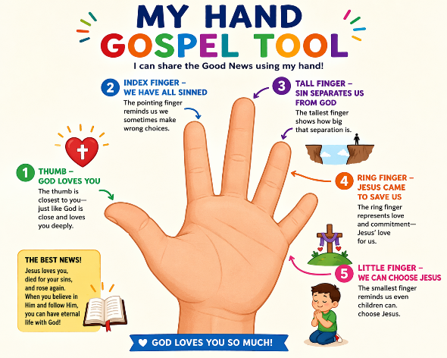  As a Witness: You share what you have seen and what you have heard about Jesus. When you tell someone:  - “God Loves You”- In what ways has God loved you?  - “We have all sinned”- In what ways have you disobeyed God?  - “Sin Separates Us from God”- In what ways has sin affected your relationship with God?  - “Jesus came to Save us”- What has Jesus saved you from?  - “We can choose Jesus”- Did you choose Jesus?
APPLICATION | The Holy Spirit gives us gifts that we can use to tell others about Jesus.  Practice telling others about Jesus:  Let the children pair up and ask them to act out short scenarios:  - Encouraging a sad friend  - Praying for someone  - Telling someone about Jesus  Then ask: Which gift did you use?
PRAYER | Dear God, thank you for giving us the Holy Spirit. Please help us to receive a message of wisdom so we can know how to help others the right way, help us to receive a message of knowledge so we can understand things you wants to show us and give us faith to trust you and tell others about Jesus. Amen
MEMORY VERSE | Acts 1:8 “But you will receive power when the Holy Spirit has come upon you, and you will be my witnesses in Jerusalem and in all Judea and Samaria, and to the end of the earth.”
CONCLUSION | The Holy Spirit teaches us what to say, shows us how to help others and helps us have faith to believe so that we can be witnesses and share Jesus with others because He is in us.
WEEKLY CHALLENGE | This week… don’t keep Jesus to yourself! Tell one friend about Jesus using the Hand Tool. Show kindness to someone. Pray for someone  👉 Say together: “I am a witness for Jesus!”

