THEME: SPIRIT LED-SPIRIT EMPOWERED
The Holy Spirit helps us tell others about Jesus in a bold and loving way. Just like He gave the disciples power and special gifts, He also gives us what we need to share God’s love with our friends, family, and community. As we learn about these gifts, we will grow in confidence, kindness, and courage to be witnesses for Jesus every day.
Heroes (7-8) Years
DATE | 26TH APRIL 2026
TOPIC | 1 Corinthians 12:7-11  The Holy Spirit Empowers Me to Witness Through His Gifts  (Word of Wisdom, Faith)
LESSON OVERVIEW | Children will understand that the Holy Spirit helps them to have faith and be brave to tell people about Jesus.
TAKE AWAY | The Holy Spirit helps me tell others about Jesus by faith.
PREPARATION | Read 1 Corinthians 12:7-11  Make sure you have visuals.
GAME | FOLLOW MY VOICE (FAITH GAME)  - One child closes their eyes  - Teacher calls them and guides them using only their voice  - Child follows the voice  Lesson Link:  You followed the voice even when you couldn’t see—that is like trusting God!
WORSHIP LEADER | Children, the Holy Spirit lives in us and helps us!  If you want Him to use you, say:👉 “Holy Spirit, use me!”  Let’s say it together! (Repeat 2–3 times)  As we worship, let’s listen carefully because God wants to speak to us.
PRAYER | Dear God, thank You for bringing us here today. Please help us listen and learn. Fill us with Your Holy Spirit and help us tell others about Jesus. Amen.
BIG WORD | Hello everyone! I’m so excited to see you today!  👉 Who remembers what we learnt last week?  Last time, we learned that telling others about Jesus is called witnessing.  Sometimes we feel:  - Shy  - Afraid  - Or we don’t know what to say  But guess what?  👉 The Holy Spirit helps us!  The Holy Spirit gives us special help in form of gifts.  Today we learn one gift that He gives us to help us be witnesses for Jesus.
CREW TIME
EXPLORE THE BIBLE TOGETHER | Let the children read these scriptures together and share what they are hearing God say through them.  1 Corinthians 12:7-11
EXPLANATION | The Holy Spirit gives us special gifts. These gifts are a chance for you to be a witness for Jesus. Remember a witness is someone who tells others what they have seen and heard. People will see what Jesus does and choose to follow Him just like you did.  - Faith- Faith means trusting God—even when it feels scary.  Remember the blindfold game, you had to have faith to believe that your friend would guide you on the path and not be hurt. In the same way you believe that God will help you and when He does, and you testify or tell someone what Jesus did, they choose to believe in Jesus.
DISCUSSION | 👉 What is Faith?  Faith is trusting God even when things seem impossible.  Remember the story in the Bible of the blind man who believed that Jesus would make him well? He was healed because he had faith.  So, imagine believing that your friend would be well and when they get healed, you tell them that they too can believe in Jesus who healed them.  That’s how the Holy Spirit helps us through the gift of faith.  👉 Were you able to tell someone about Jesus this week? How does it feel?  👉 Remind the children about the Hand as a tool to tell others about Jesus  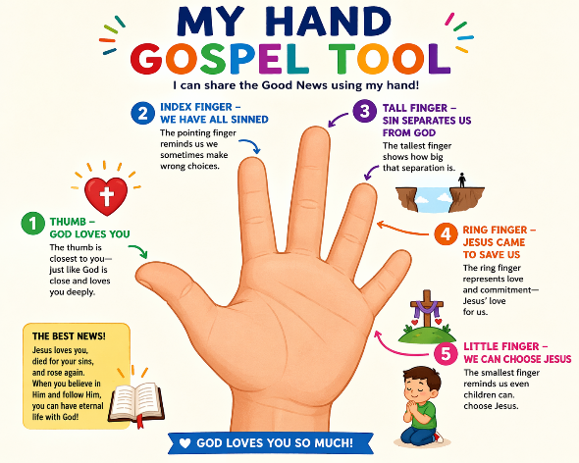  As a Witness: You share what you have seen and what you have heard about Jesus. When you tell someone:  - “God Loves You”- Tell someone what God has done for you  - “We have all sinned”- Tell someone what you did that made God sad  - “Sin Separates Us from God”- Tell someone how making God sad made you feel.  - “Jesus came to Save us”- Tell someone that Jesus loves them.  - “We can choose Jesus”- Tell someone that they can choose Jesus just like you.
APPLICATION | The Holy Spirit gives us gifts that we can use as a chance to tell others about Jesus.  Practice telling others about Jesus:  Let the children pair up and ask them to act out at least one of these short scenarios:  - Encouraging a sad friend  - Telling someone about Jesus
PRAYER | Dear God, thank You for the Holy Spirit. Help me speak, understand, and be brave.  Help me tell others about Jesus. Amen
MEMORY VERSE | Acts 1:8 “But you will receive power when the Holy Spirit has come upon you, and you will be my ...”
CONCLUSION | The Holy Spirit shows us how to help others by giving us the gift of faith to believe so that we can be witnesses and share Jesus with others.
WEEKLY CHALLENGE | This week, tell one friend about Jesus using the Hand Tool.  👉 Say together: “I am a witness for Jesus!”

